Practical - 11
Practical Title: Student Management CRUD with Search and Filter.

Create a student management module to add, view, edit, delete, search and filter student records. All database operations must use MYSQLi statements and clear success/failure messages.

Theory

1. Answers to key questions
1. Are SELECT, INSERT, UPDATE, and DELETE operations working?
Yes. SELECT displays student records, INSERT adds new records, UPDATE edits existing records, and DELETE removes records from the database.
2. Is search by name/email/course implemented?
Yes. A search input can filter student records by name, email, or course using a prepared SQL statement.
3. Are delete operations confirmed before execution?
Yes. A JavaScript confirmation dialog asks the user to confirm before deleting a student record.

Implementation/ Output/Result :

• Created a student management interface.
• Connected PHP to the MySQL database using MySQLi.
• Implemented SELECT to display student records.
• Implemented INSERT to add student records.
• Implemented UPDATE to edit student details.
• Implemented DELETE with confirmation.
• Added search by name, ID or course.
• Displayed appropriate success and failure messages.

Output(Screenshots):
Main DashBoard where you can add ,delete,Edit and filter Student Record:
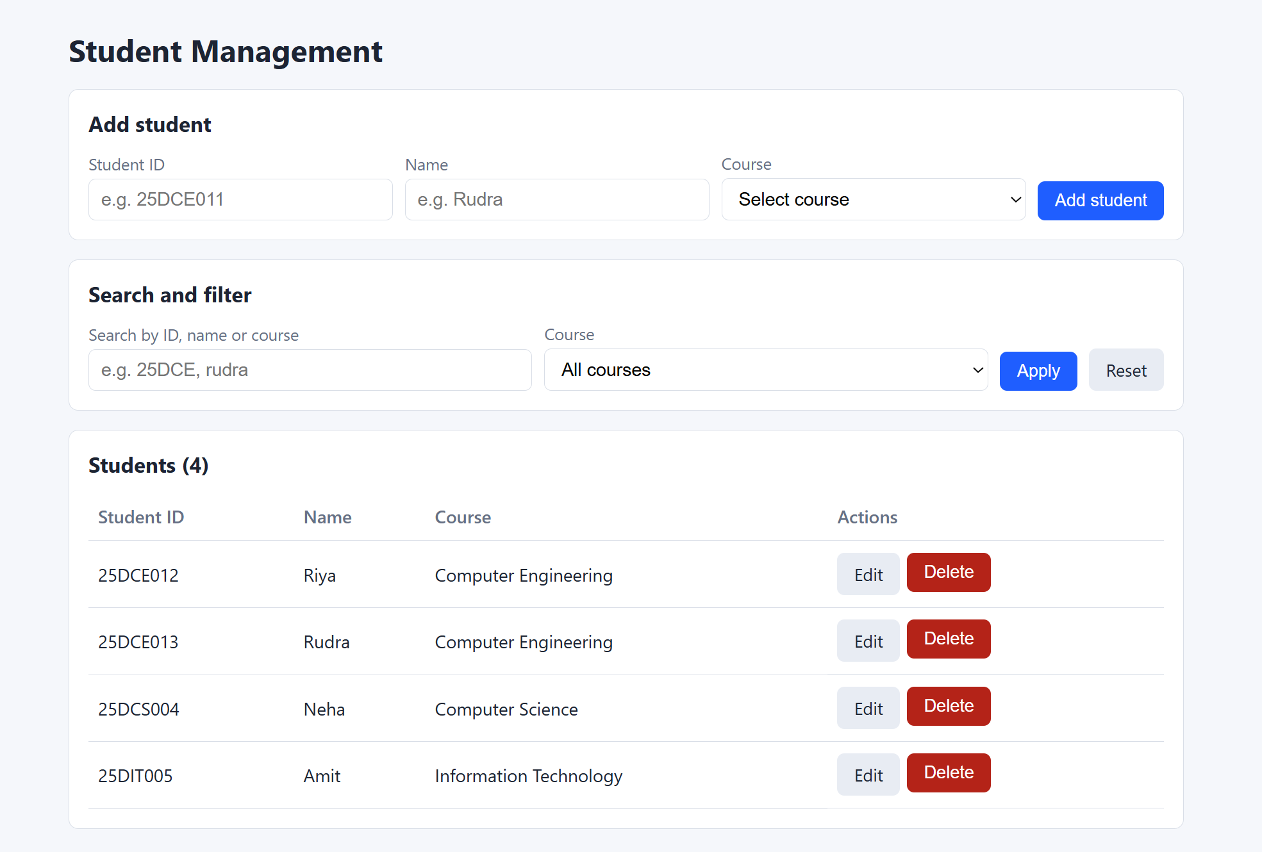

Add Student Details:
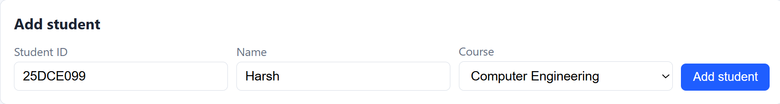

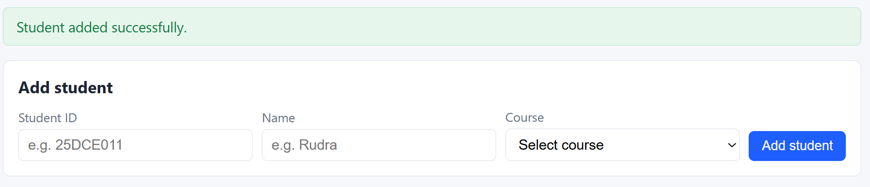

You can see it in List of Students below:
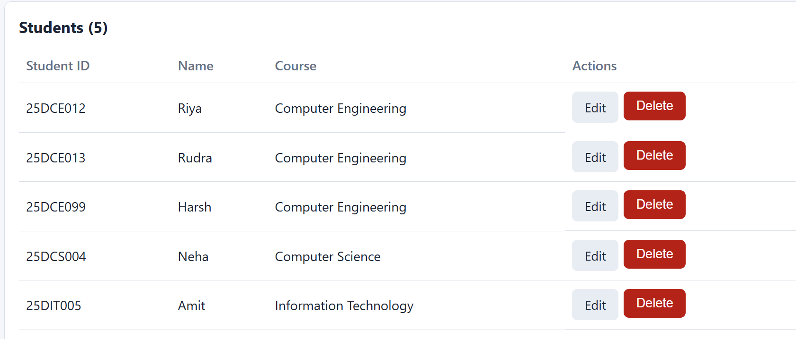

Edit Student(Harsh) Record by changing his name to Harshit:
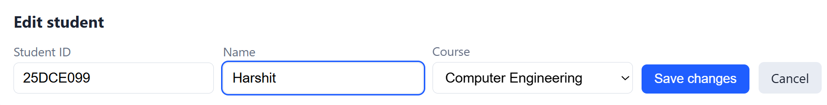
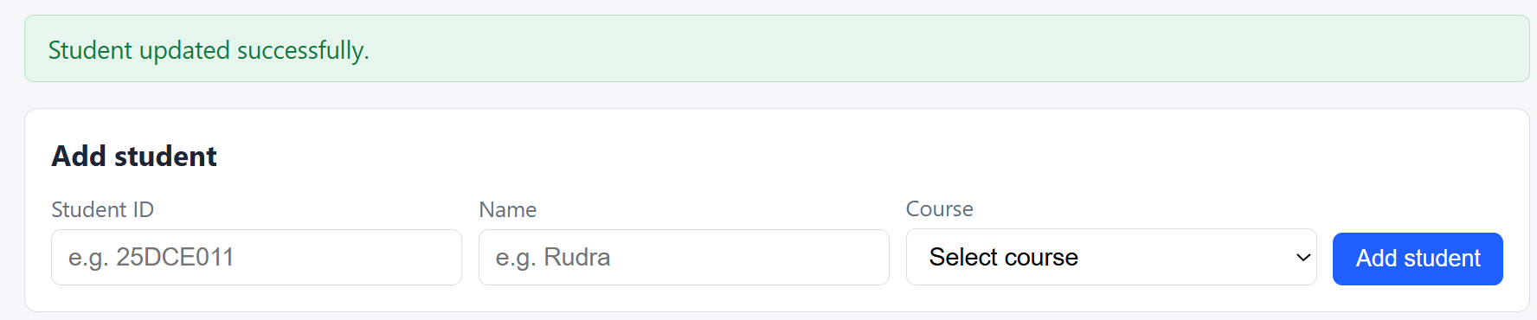

You can see below:
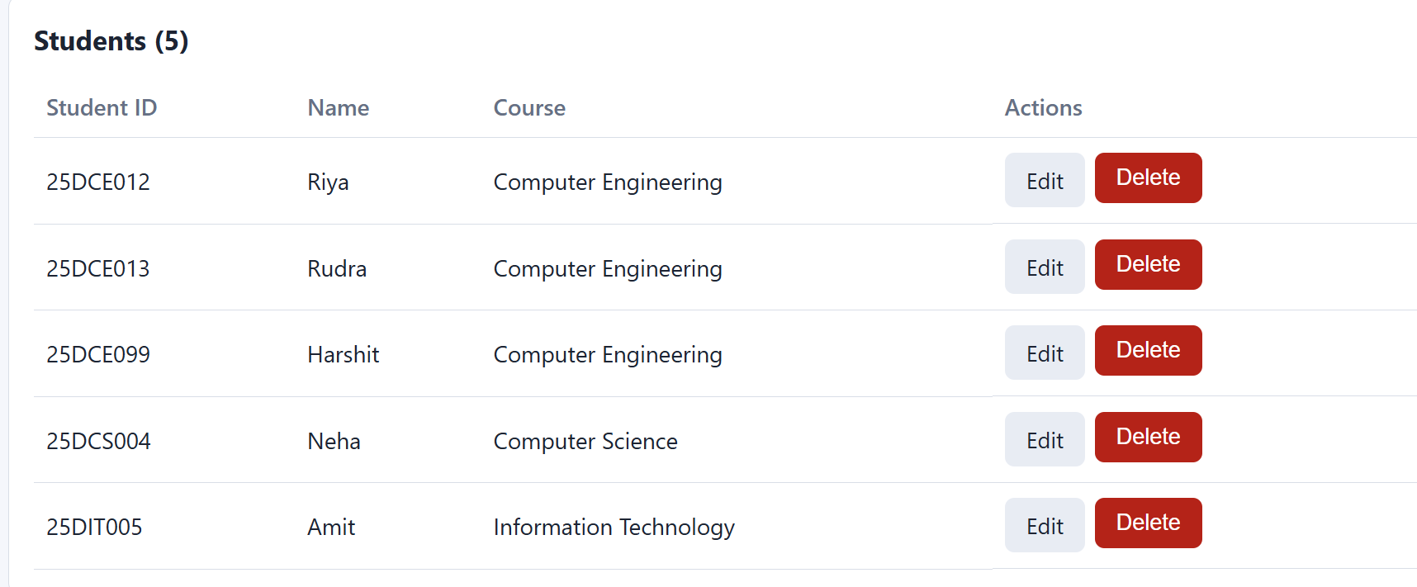

Search Student Record:
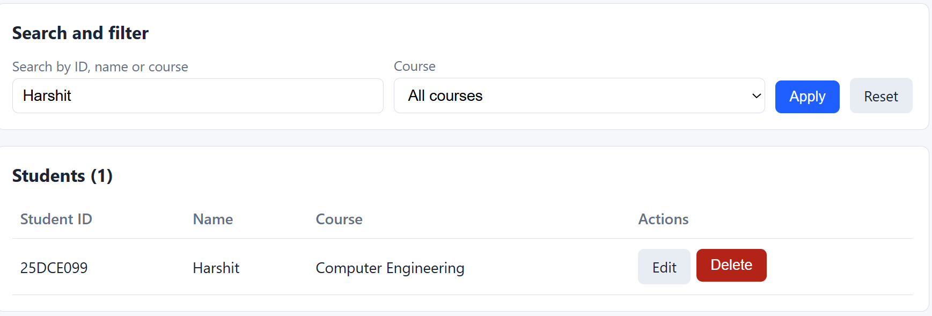

Delete Record(Harshit):
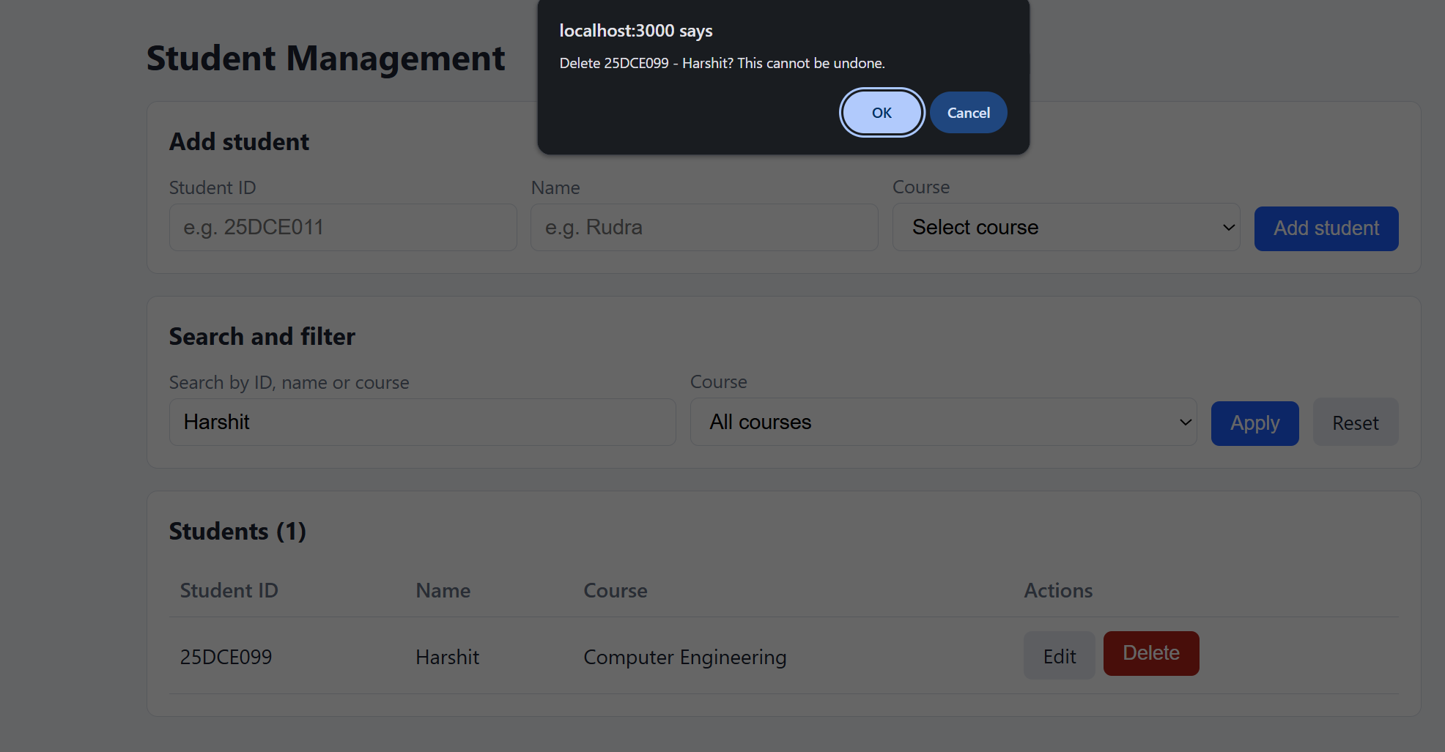
No Record of Harshit:
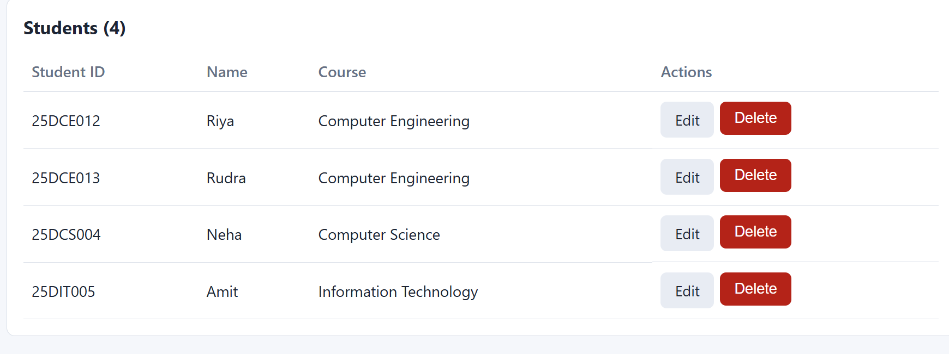

GitHub Repository Link:
https://github.com/HimeshMale/Student-Hub-Portal

Learning Outcomes:
Learned to implement secure student CRUD operations with MySQLi, search, filtering, and user feedback.

Faculty Remarks:

